Code:

data['Date'] = pd.to_datetime(data.Date,format='%Y/%m/%d %H:%M:%S')

data.index = data['Date']

plt.figure(figsize=(16,8))

plt.plot(data['Close'], label='Close Price history',color='g')

plt.xlabel('Date',size=20)

plt.ylabel('Stock Price',size=20)

plt.title('Stock Price of Microsoft over the Years',size=25)

def lstm_prediction(df):

shape=df.shape[0]

df_new=df[['Close']]

df_new.head()

dataset = df_new.values

train=df_new[:ceil(shape*0.75)]

valid=df_new[ceil(shape*0.75):]

print('-----------------------------------------------------------------------------')

print('-----------STOCK PRICE PREDICTION BY LONG SHORT TERM MEMORY (LSTM)-----------')

print('-----------------------------------------------------------------------------')

print('Shape of Training Set',train.shape)

print('Shape of Validation Set',valid.shape)

scaler = MinMaxScaler(feature_range=(0, 1))

scaled_data = scaler.fit_transform(dataset)

x_train, y_train = [], []

for i in range(40,len(train)):

x_train.append(scaled_data[i-40:i,0])

y_train.append(scaled_data[i,0])

x_train, y_train = np.array(x_train), np.array(y_train)

x_train = np.reshape(x_train, (x_train.shape[0],x_train.shape[1],1))

model = Sequential()

model.add(LSTM(units=50, return_sequences=True, input_shape=(x_train.shape[1],1)))

model.add(LSTM(units=50))

model.add(Dense(1))

model.compile(loss='mean_squared_error', optimizer='adam')

model.fit(x_train, y_train, epochs=1, batch_size=1, verbose=2)

inputs = df_new[len(df_new) - len(valid) - 40:].values

inputs = inputs.reshape(-1,1)

inputs = scaler.transform(inputs)

X_test = []

for i in range(40,inputs.shape[0]):

X_test.append(inputs[i-40:i,0])

X_test = np.array(X_test)

X_test = np.reshape(X_test, (X_test.shape[0],X_test.shape[1],1))

closing_price = model.predict(X_test)

closing_price = scaler.inverse_transform(closing_price)

rms=np.sqrt(np.mean(np.power((valid-closing_price),2)))

print('RMSE value on validation set:',rms)

print('-----------------------------------------------------------')

print('-----------------------------------------------------------')

valid['Predictions'] = closing_price

plt.plot(train['Close'])

plt.plot(valid[['Close','Predictions']])

plt.xlabel('Date',size=20)

plt.ylabel('Stock Price',size=20)

plt.title('Stock Price Prediction by Long Short Term Memory (LSTM)',size=20)

plt.legend(['Model Training Data','Actual Data','Predicted Data'])

Output:

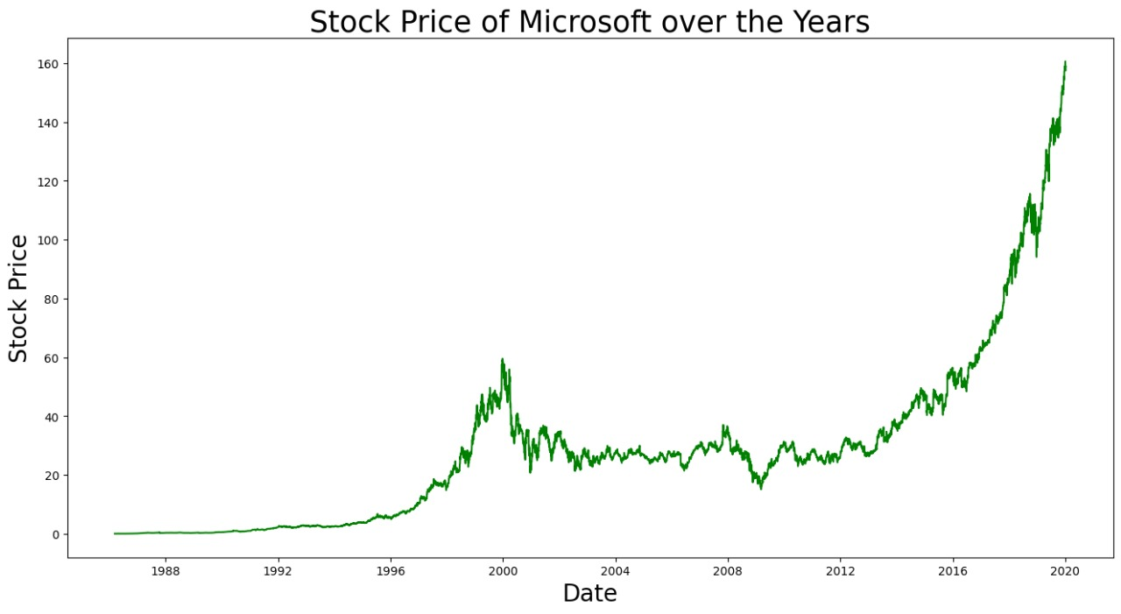

-----------------------------------------------------------------------------

-----------STOCK PRICE PREDICTION BY LONG SHORT TERM MEMORY (LSTM)-----------

-----------------------------------------------------------------------------

Shape of Training Set (1134, 1)

Shape of Validation Set (377, 1)

1094/1094 - 19s - loss: 4.5201e-04

RMSE value on validation set: Close 9.464954

dtype: float64

-----------------------------------------------------------

